CS 542

Midterm Study Guide (Theory 60%) (Calculations 40%)

Params:

* Vocabulary
* T/F with corrections
* Short Answer (How/Why)
* Diagrams (Draw/Explain)

**Vocab:**

|  |  |
| --- | --- |
| PSTN – Public Switched Telephone Network | ISO – Intl. Standard Organization |
| DSL – Digital Subscriber Line | CDMA – Code-Division Multiple Access |
| DSLAM – Digital Subscriber Line Access Multiplexer | LTE – Long-Term Evolution |
| FTTH – Fiber to the Home | Wi-Fi – Wireless Fidelity |
| FDM/TDM – Freq./Time Division Multiplexing | TCP – Transmission Control Protocol |
| AON/PON – Active/Passive Optical Network | RFC # - Request for Comments |
| HFC – Hybrid Fiber Coaxial | *IETF – Internet Engineering Task Force* |
| HTTP – Hypertext Transport Protocol | *IEEE – Institute of Electrical and Electronics Engineers* |
| *LLC – Logical Link Cable* | *MAE – Metropolitan Area Exchanges* |
| *URL – Universal Resource Locator* | *Aloha – Additive Links On-line Hawaii Area* |
| *MSS – Max. Segment Size* | *MAC – Media Access Control* |
| *MTU -Max. Transmission Unit* | *CRC – Cyclic Redundancy Check* |
| *ARQ – Auto Repeat Request* | DS-0 – Digital Signal Zero |
| *FCS – Frame Check Sequence* | T-1 - Tier 1 |
| *HTML – Hypertext Markup Language* | UDP – User Datagram Protocol |

**1.1:**

* *Protocols* define *format, order of messages sent/received,* and *action*

**1.2**

* *Network edge (hosts/servers)*
* *Network Core (interconnected routers/NW of NWs)*
* ***Know structure of internet***
* ***Diagrams:***
  + ***DSL Architecture***
  + ***Cable NW***
  + ***PON/AONs***

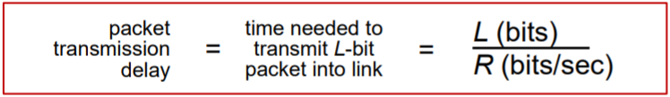

**1.3:**

* **Routing and forwarding (tables)**
  + Store and fwd
* **EXAMPLE:** How long does it take to send a file of 100 MB from host A to host B over a core PSTN? (1000 Km distance between host A and host B)
* **PKT SW vs CSW**
* Internet Structure:
  + NSP
    - <NAPs/MAEs (IXPs): ***Tier 1***
      * <Regional ISPs: ***Tier 2*** 
        + <Local ISPs ***Tier 3***

<End Customer

**1.4**

* Packet loss and delay



* ISO/OSI reference Model:
  + Application
  + Presentation
  + Session
  + Transport
  + Network
  + Data Link
  + Physical
* Ethernet Frame (**64 – 1518 Bytes)**

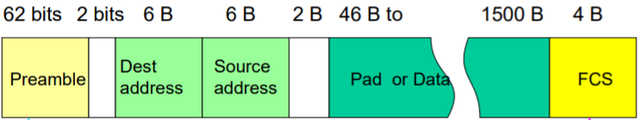

**2.1**

* Server: always on host w/permanent IP (scalable with data centers)
* Clients: communicate w/server
* **P2P Architecture**
  + **Challenges:** ISP Friendly, Security, Incentives
* App Transport Services:
  + Data integrity
  + Throughput
  + Timing
  + Security
* **TCP vs. UDP**

|  |  |
| --- | --- |
| TCP:   * Reliable transport * Flow control * Connection-oriented (handshake) * **No timing, min throughput, security** | UDP:   * Unreliable data transfer |

**2.2**

* **HTTP USES TCP (STATELESS)**
  + **Persistent vs. non-Persistent connection (keep alive vs. pipelining)**
    - **2RTT+transmission time** for each non-persistent object
  + FUNCTIONS OF HTTP MESSAGES (request and response messages):
    - GET – (used by URL)
    - POST – upload data to server
    - HEAD – ask host to leave out object from response
    - PUT (http1.1) – upload file in entity body to path specified in URL field
    - DELETE (http1.1) – deletes file in URL field
* **COOKIES**
  + Maintain sender state over multiple transactions
* **PROXY SERVER**
  + Satisfy client req without origin server
  + Acts as a ***web cache***
    - ***EXAMPLE:***
* cache hit rate is 0.4
* origin servers 1.54 Mbps access link
* 60% of requests use access link
* data rate to browsers over access link ***= 0.6*1.50 Mbps = .9 Mbps***
* utilization ***= 0.9/1.54 = .58***
* total delay = Internet Delay + access delay + LAN delay

= 0.6 (2.01) + 0.4 (~msecs) = ~ 1.2 secs

* + Uses **CONDITIONAL-GET <If-modified-since: {date}>**

**2.X**

* FTP
  + Contact server over port 21
  + TCP data connect over port 20

**2.3**

* EMAIL (SMTP)
  + TCP over Port 25
    - Handshaking
    - Msg transfer (7-bit ASCII)
    - Closure
* **SMTP vs. HTTP** 
  + **Smtp: push**
  + **Http: pull**
* **POP3:**
* **IMAP**

**2.4**

* DNS: Domain Name System
  + App layer protocol
  + Hostname 🡨 🡪 IP resolution
  + Struct:

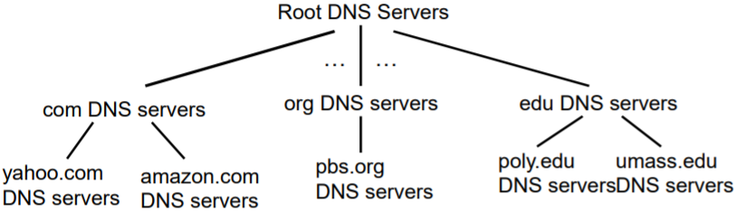

* + **Root Serves**
    - Contact authorative if mapping not known
    - Return mapping to local name server
  + **TLD (Top-Level Domain) Servers**
  + **Authoritative servers**
  + **Local DNSs**
  + 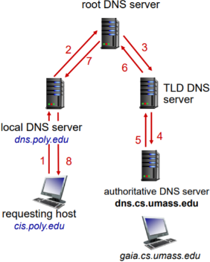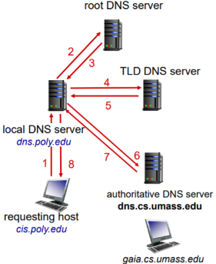**ITERATIVE QUERY RECURSIVE QUERY**

**2.7**

* Socket Programming
  + Build client/server apps that communicate through sockets
  + UDP or TCP

**3.1 & 3.2 Transport Layer Services and Multiplexing/Demux**

**3.3**

* UDP Connectionless transport
  + 32 bits header ( src port | dest port | length | checksum | PAYLOAD )